

**KHULNA UNIVERSITY OF ENGINEERING & TECHNOLOGY**

**Department of Computer Science and Engineering**

Course Title: Mobile Computing Laboratory

Course No. : CSE 3218

Project Report on iOS: Hotel Booking App

**Date of Submission:** 28 November, 2023

|  |  |
| --- | --- |
| **Submitted By** | **Submitted To** |
| Habibur Rahman(1907036)  Ehsanul Karim(1907039)  Mashhura Mashfi(1907040)  Afiat Khan Tahsin(1907047)  Ankon Chowdhury(1907048)  Year: 3rd Semester: 2nd  Department of Computer Science and Engineering (CSE)  Khulna University of Engineering and Technology (KUET), Khulna-9203 | **Most. Kaniz Fatema Isha**  Lecturer **Argha Chandra Dhar**  Lecturer  Department of Computer Science and Engineering (CSE)  Khulna University of Engineering and Technology (KUET), Khulna-9203 |

**Introduction:**

* 1. **Background:**

The iOS Hotel Booking app HEMAA is designed to facilitated the hotel booking process for users. It’s really a hassle for tourist to search for hotels during a vacation in a unknown city. Our app HEMMA is here to guide the tourists solving the problem, tourist can book hotel prior to their visit and thus they can enjoy a peaceful and perfect vacation.

* 1. **Objectives and goals of the project:**

The app is mainly focusing on building a perfect platform for tourist to find a hotel with their IOS mobile. Many special features like providing hotel descriptions, hotel name, some snapshots of the hotels surrounding, the ratings of that hotel and the price is shown. Also, a user can create an account in this app, and he can book a hotel with of his liking. Also, HEMAA used the Rapid API for hotel information and Firebase Real-time Database for user data.

The primary objectives of the project include:

1. Implementing user authentication through Firebase.
2. Displaying hotel information from the RAPID API on the homepage.
3. Enabling users to book hotels with details such as check-in and check-out dates, room fare, and the number of rooms.
4. Design an easy-to-navigate interface for users to browse hotels, select rooms, and make booking effortlessly.
5. Recommendation of some good hotels in the User homepage.
6. Implement a searching system to allow users to find hotels based on price, rating and other preferences.
7. Allow users to see the rate and review hotels.
8. Calculating and displaying the total fare for a booking.
9. Implementing a booking history page to track user reservations.

**Methodology:**

2.1: Description of Methods and Procedures:

**Views:**

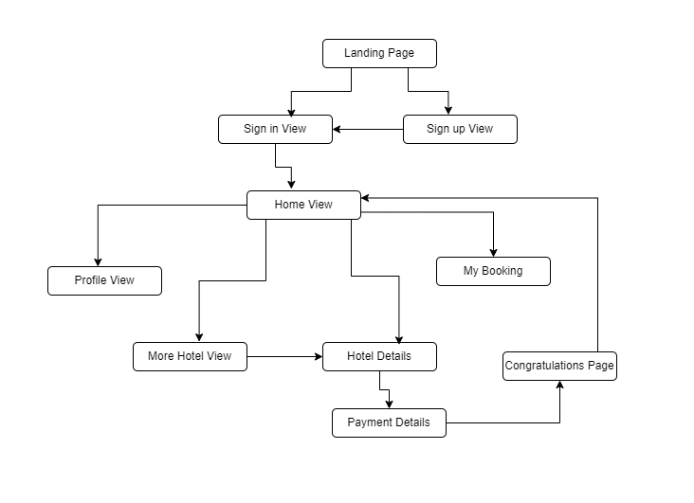

Figure 1: Flow diagram of the app

This flow diagram represents the working flow of our entire app. During the execution the app goes by many procedures such as:

**Utilizing Firebase Authentication:** the app ensures secure user login and registration. A dedicated authentication manager class was created to handle interactions with Firebase Authentication. Methods in this class include user registration, login, password reset, and sign-out.

**User Model:** A user model class was designed to represent user data, including attributes such as username, email, and a unique identifier. This class facilitates the mapping of Firebase user data to a local model for efficient handling within the app.

**API Manager:** Several manager classes were used to communicates with the RAPID API server to retrieve hotel data. Such as hotel details, summary, review info, property gallery, location etc. We tried to ensure a smooth flow of data between the API and the app. The homepage displays hotel information fetched from the RAPID API server.

**Hotel Model:** A model class represents hotel data and it’s created with some of the retrieved data from the API, like hotel name, location, and available rooms. Instances of this class are created to upload the booked hotel selected by the users to the Firebase Database

**Booking Process logic:** The booking process involves allowing users to enter check-in and check-out dates, select the number of rooms, and calculate the total fare.

**Booking List Model:** A model class represents a booking, including attributes like check-in date, check-out date, number of rooms, total fare, user name, hotel name and night to be stayed. Instances of this class are created during the booking process and stored in the Firebase Real-time Database.

**Firebase Real-time Database:** The Firebase Real-time Database is employed for storing and retrieving user data, including booking history.

**Class Diagram:**

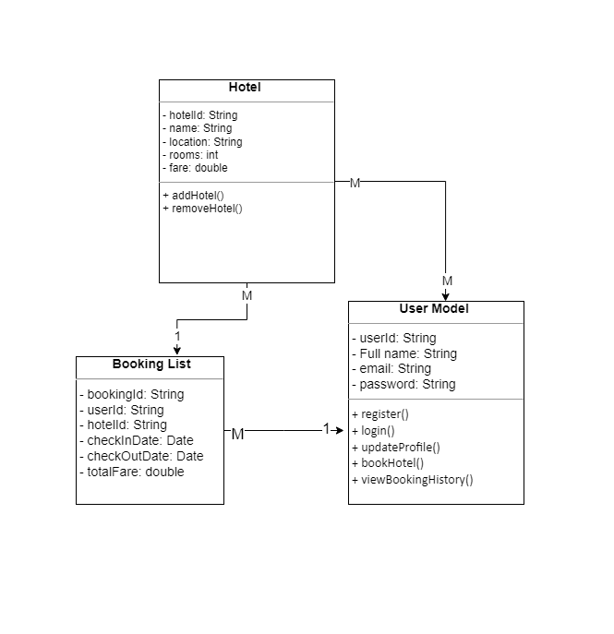

Figure 2: Class diagram of the app

**Results:**

**Functionality Showcase:**

Attached are screenshots of the app showcasing the following features:

*Landing Page, Sign in page and Sign Up page:*

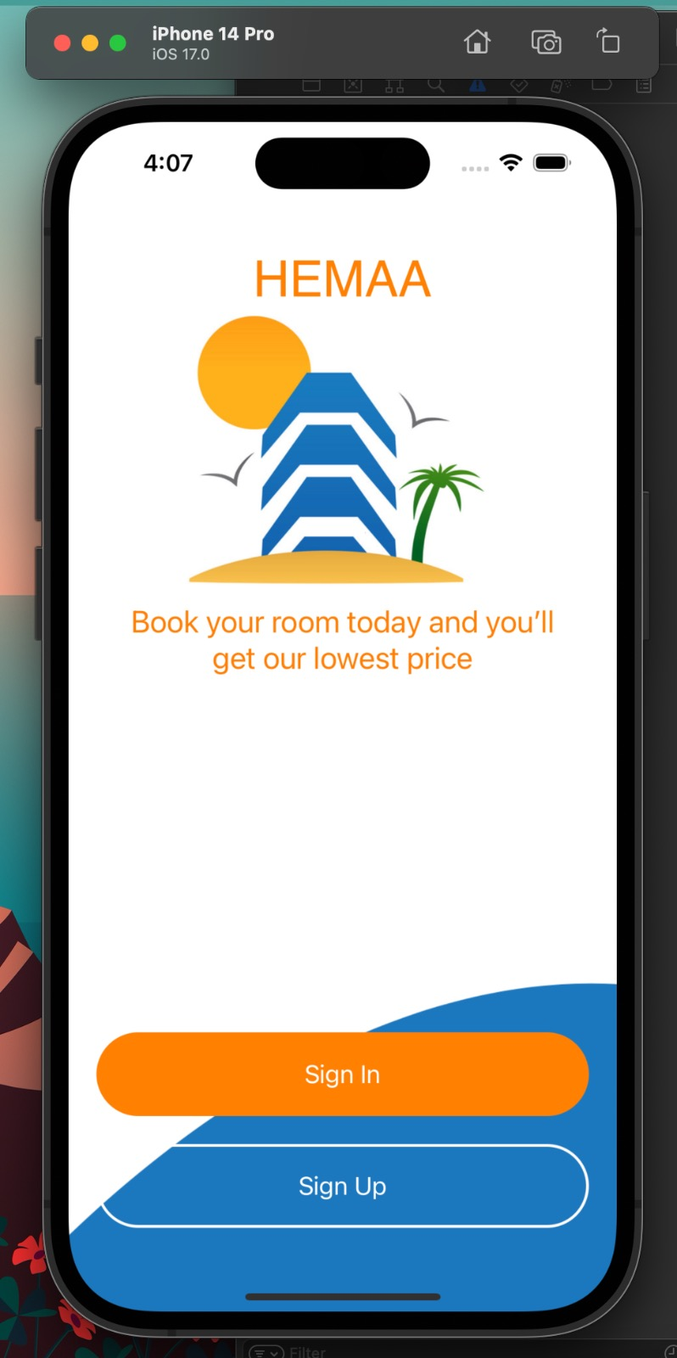

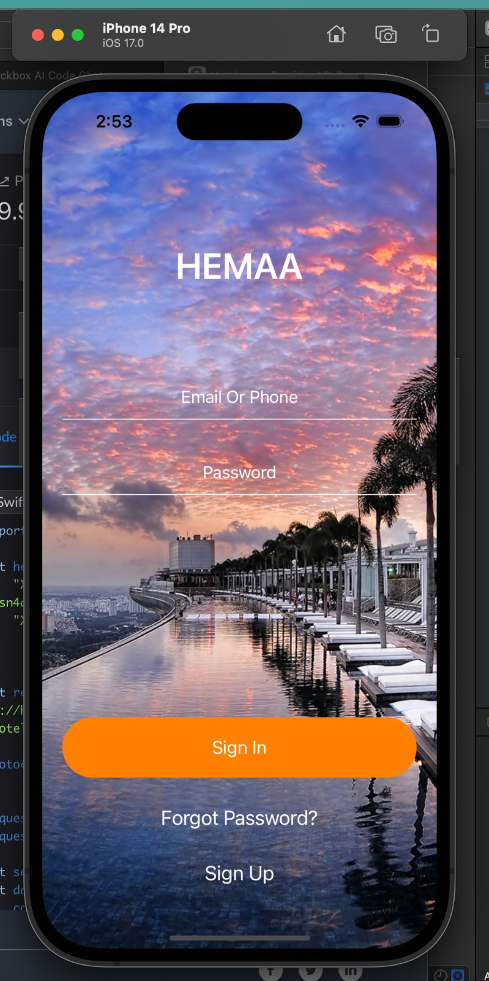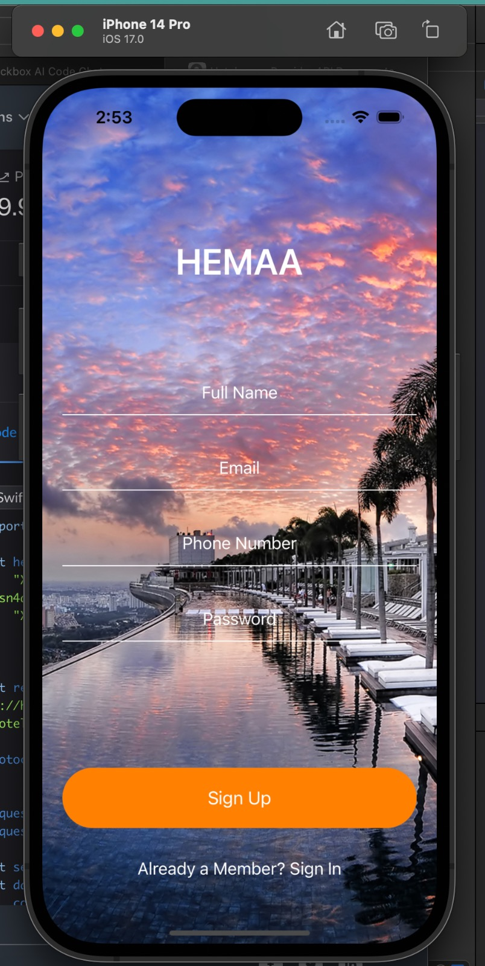

*Homepage*: Displaying hotel information.

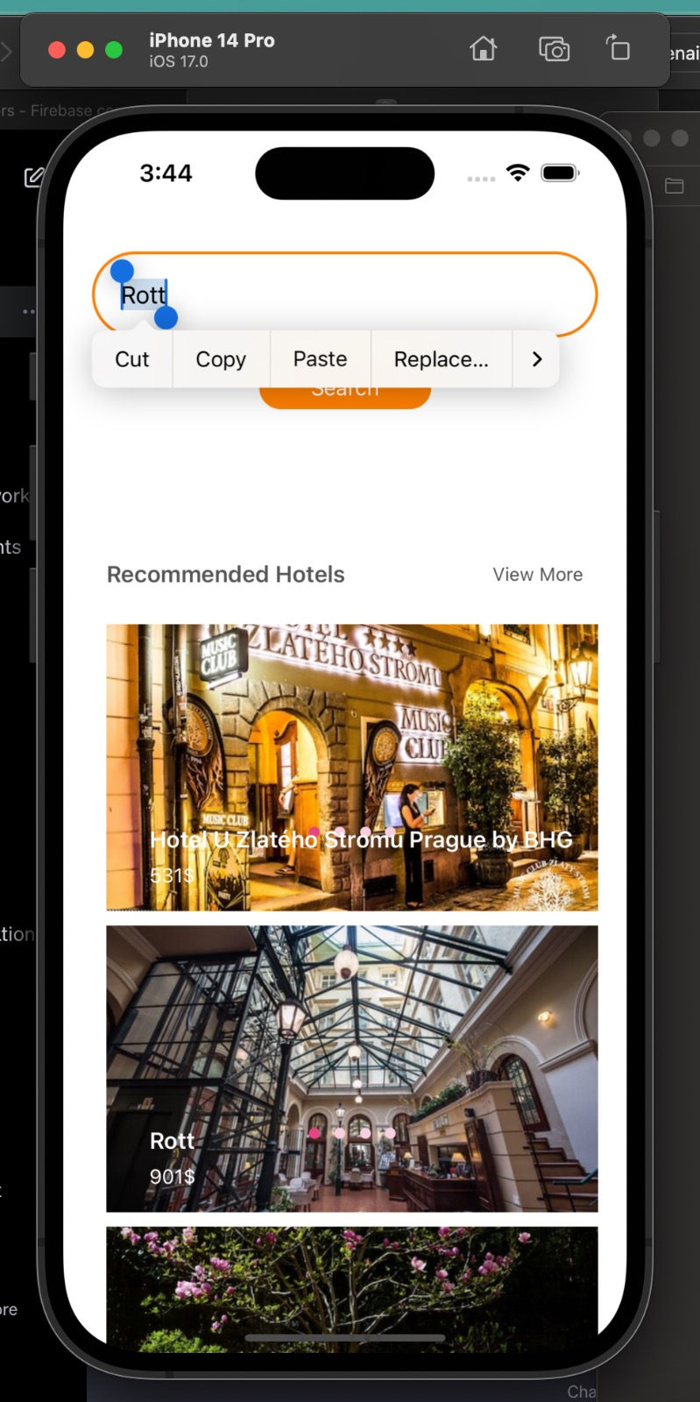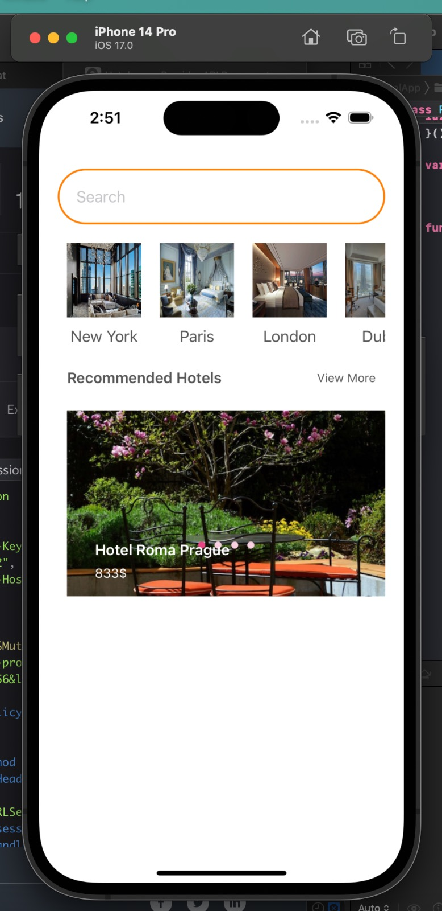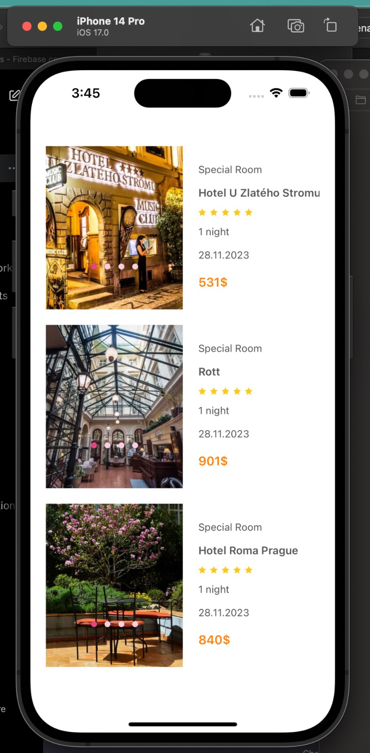

*Details Page*: showing the details of the selected hotel,

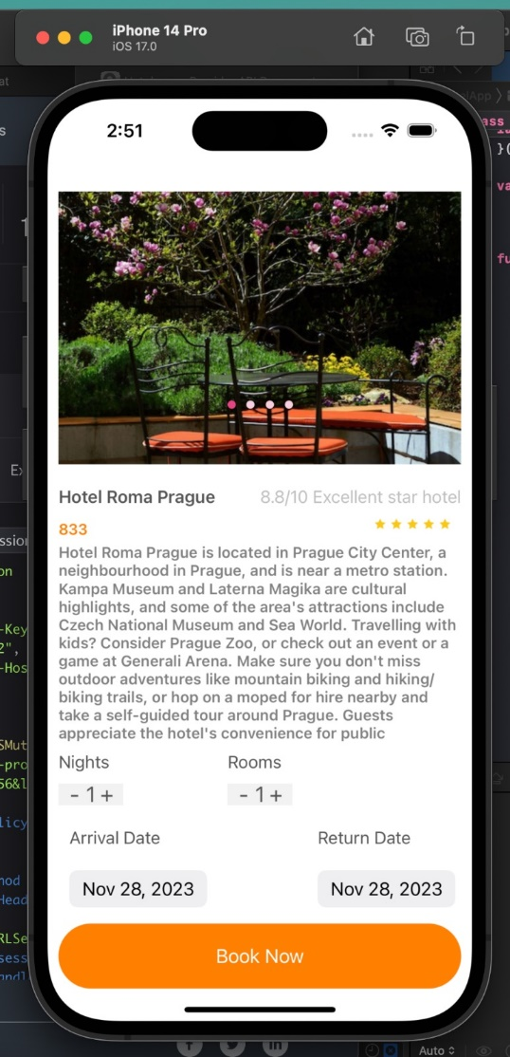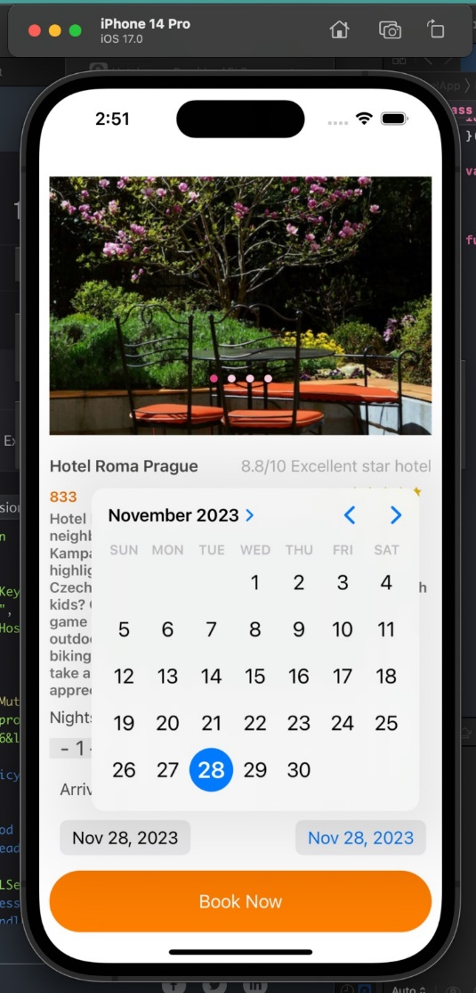

*Payment, Booking list & Profile page*: Displaying the calculated fare for a booking.

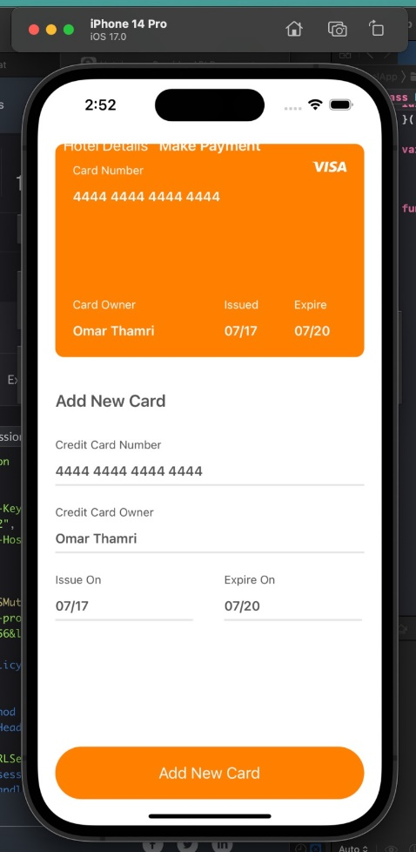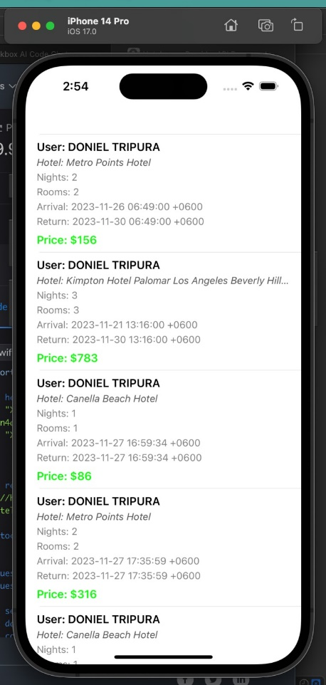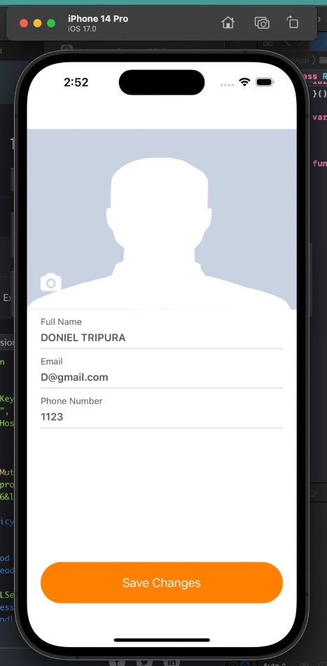

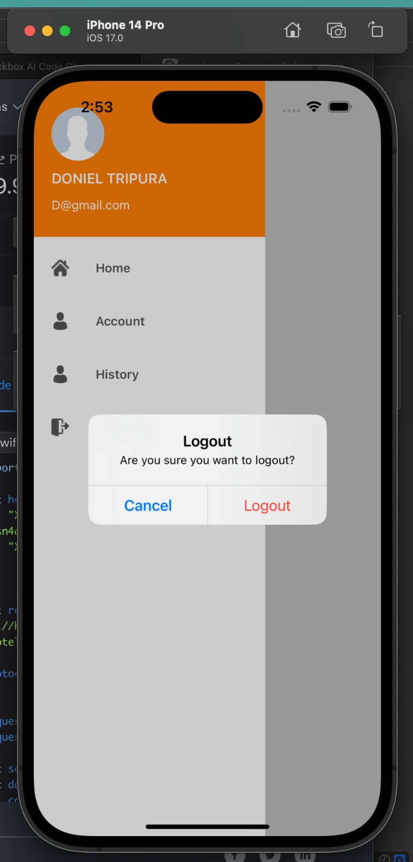

*Logout*: Session ends for user who is currently logged in.

**Discussion:**

Hemaa, an ios hotel booking app is developed with the goal of solving tourist difficulty caused by their first time arrival or the pricing problem. Our app perfectly fits in the jar of this problem. After a long time of hard-work, our app is fully functional and successful in working the way we wanted to develop. And also, solving the problems we wanted to solve. Our app navigates a user to the hotels in a particular city and leads him to check for the pricing and also the availability. The user can check the rating and the condition of the rooms with the information showed in the storyboard. With that the user can book rooms for a specific time and calculate his expenses which is directly pushed to our database. We used Swift, UIKIT, Rapid Api, Firebase and logic explaining techniques in the making and developing of our app.

**Conclusion and Future Work:**

In conclusion, the iOS Hotel Booking app, developed with Swift, UIKit, RAPID API, and Firebase, stands as a well-rounded solution for hotel booking. The app's current state showcases successful implementation and integration of various technologies, laying a solid foundation for future enhancements and feature additions.

Future work may include:

1. Implementing a payment gateway for actual transactions.
2. Enhancing the user interface and experience.
3. Integrating additional features such as user reviews and ratings.

After all, we are satisfied with our app and also thankful to our teachers to help us in the journey of building a perfect ios project.

**References:**

1. <https://rapidapi.com/tipsters/api/hotels-com-provider/>
2. <https://firebase.google.com/docs/database/ios/read-and-write>
3. https://developer.apple.com/documentation/uikit